**Uses of Ionizing Radiation**

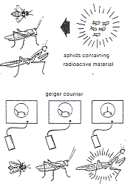Ionizing radiation has many applications, but care must be taken as it can be hazardous to human health.

**Uses of isotopes in agriculture**

**Pest control**

Small pests (e.g. aphids, as seen in the diagram to the right) can be sprayed with radioactive materials. Some time later, a range of predators in the area are captured. The main predator of the pest can easily be identified as it will be the one that has the largest quantity of the radioactive isotope inside it. This knowledge is then used when releasing natural predators to provide biological control of pests.

**Sterile insect technique**

Male insects can be sterilised using gamma radiation and then released into the wild. They mate with females which then lay eggs that are infertile. Over time, this reduces the population of that insect.

**Tracers in plants**

Phosphorus is an important part of the chemical processes involved in the growth and reproduction of plants. Phosphorus‑32 is a radioactive isotope of phosphorus, but since it is chemically similar to the non-radioactive phosphorus‑31, it is used in the same way by the plant. Phosphorus-32 can be injected into the roots of the plant. A Geiger counter is then used to detect the movement and concentration of the phosphorus-32 throughout the plant, helping biologists gain a more precise understanding of how the plant grows and reproduces.

**Uses of isotopes in manufacturing and industry**

**Thickness gauges**

The image to the left shows a radiation source and detector being used to control the thickness of a rolled sheet of plastic (this technique can also be used for paper or metal).

Beta radiation is used as it can be stopped by thicker metal but passes through thinner metal. If the material is too thick, the reading decreases and the rollers are adjusted to make the material thinner. The opposite occurs if the reading is too high.

**Identifying leaks in underground pipes**

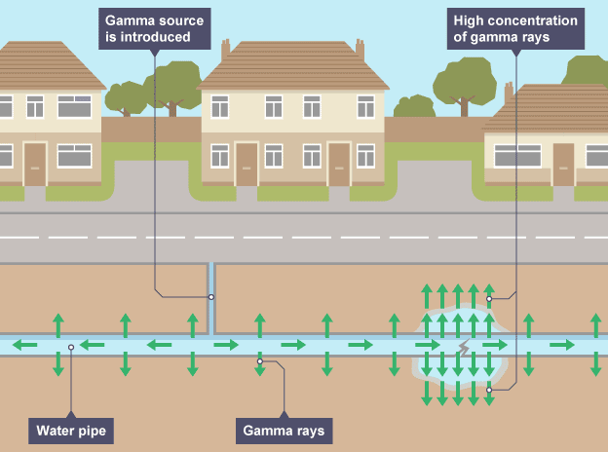

Leaks in underground pipelines can be detected by adding a small amount of a gamma-emitting radioisotope to the fluid. An area above ground where a high concentration of radiation is detected corresponds to a leak in the pipe. This saves time and effort as only the damaged section needs to be dug up.

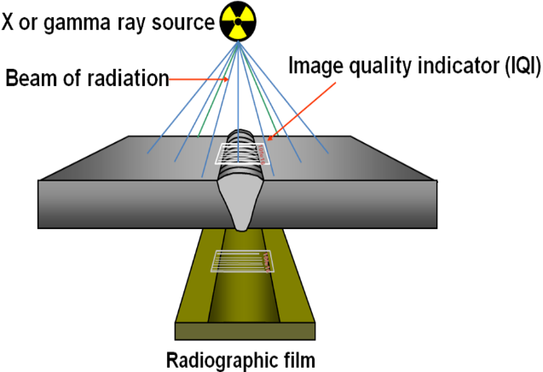**Identifying gaps in welds**

This method of weld testing makes use of gamma rays. Penetrating radiation is passed through a weld onto a radiographic film, resulting in an image of the object's internal structure being formed on the film. The amount of energy absorbed by the object is proportional to its thickness and density. Energy not absorbed by the object will cause exposure of the radiographic film. These areas will be dark when the film is developed. Areas of the film exposed to less energy remain lighter. Therefore, areas of the object where the thickness has been changed by discontinuities, such as porosity or cracks, will appear as dark outlines on the film.

